Meaningful Use-Core Criteria

Core Criteria #1

* **Certified Provider Order Entry (CPOE)**
* 30% of all prescriptions (new or refills) written within the system must be entered by licensed healthcare professional.
* This includes MD, PA, NP & LPN (Rae)
* Make sure that all Certified Providers have their licensure listed in their demographics.(chart>demographics>providers/PA/NP/clinical staff>search for staff>edit>licensure tab)
* No issues meeting this criterion for the Meaningful Use (MU) incentive.

Core Criteria #2

* **Implement drug-drug and drug-allergy interaction checks.**
* All staff that are involved in prescription writing need to make sure that this feature is turned on.
  + After 7.0 update
  + Go to Chart module>click on file>options>ScriptWriter
  + It doesn’t matter what level of interactions is selected, so I would recommend: Major & Above Interactions and Contraindicated only to prevent interaction overload
* 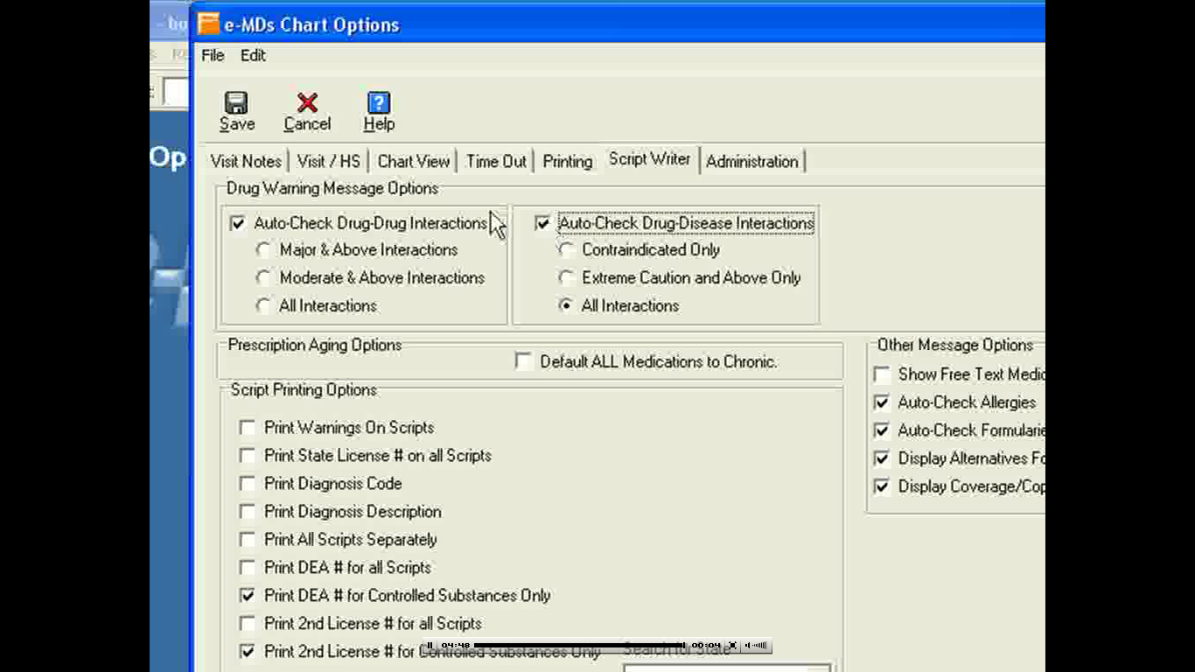
* No issues meeting this criterion for the Meaningful Use (MU) incentive. We are already doing this.

Core Criteria #3

* **Generate and transmit permissible prescriptions electronically (eRx)**
* 40% of all non-schedule drug prescriptions must be generated & transmitted electronically.
* This is done thru SureScripts
* All staff who are involved in prescription writing need to make sure that this feature is turned on.
  + After 7.0 update
  + Go to Chart module>click on file>options>ScriptWriter
* 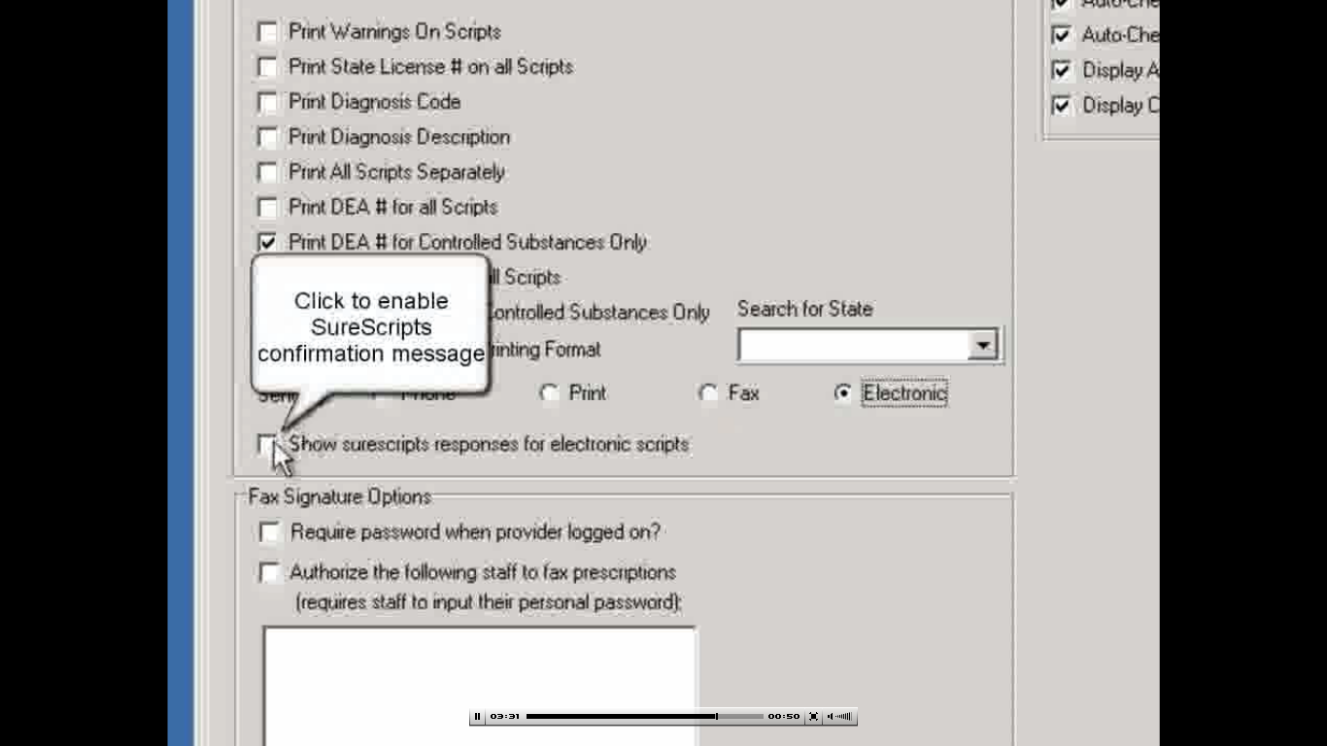
* No issues meeting this criterion for the Meaningful Use (MU) incentive. We are already doing this.

Core Criteria #4-6

* **#4-Maintain an up-to-date problem list of current and active diagnoses.**
* **#5-Maintain active medication list.**
* **#6-Maintain active medication allergy list.**
* 80% of all patients seen must have upt-to-date list of current diagnoses, medication, and medication allergies.
* This is done thru Visit/HS
* This will be the responsibility of the nursing staff
* *\*\*This must be done at every visit.\*\**
* 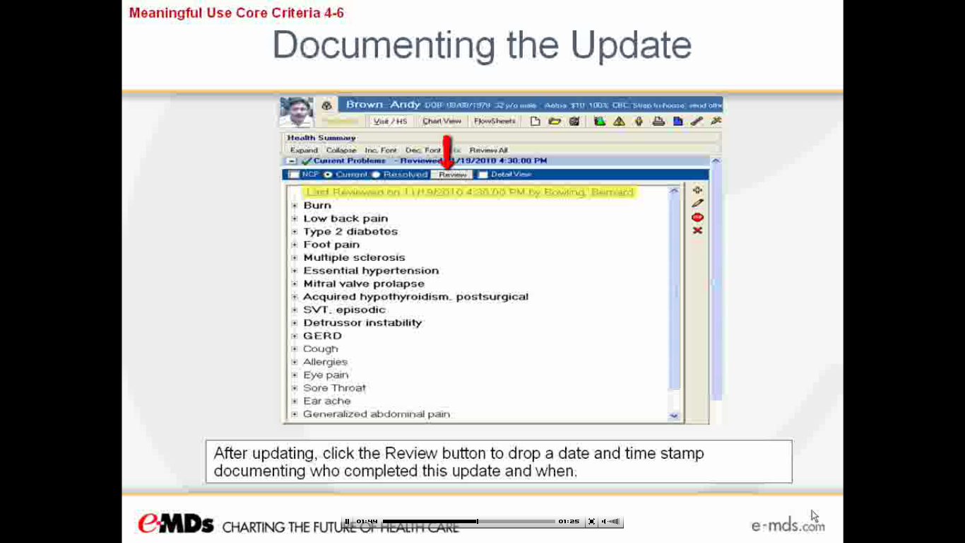
* FYI-if there are diagnoses that are the same (ie. Mixed hyperlipidemia & hyperlipidemia) you can click and hold one dx and move it over the over similar dx to combine them.
* If they do not have any current problems, allergies or medications, you MUST note this by clicking the box.
* 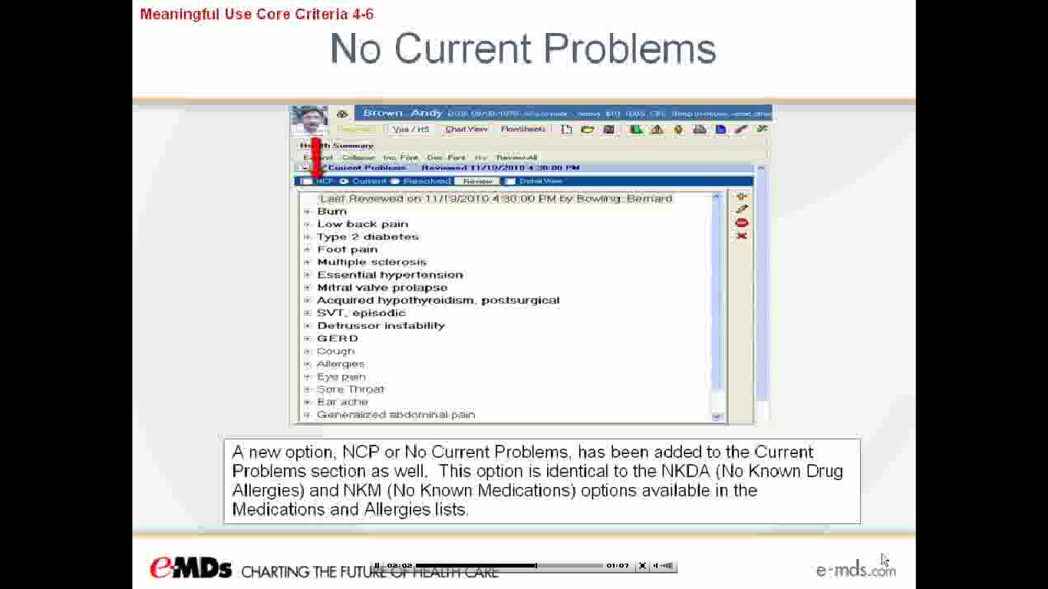

Core Criteria #7

* **Record all of the following demographics: Preferred language, Gender, Race, Ethnicity & Date of Birth.**
* This information must be documented on 50% of all patients to qualify for Meaningful Use incentive.
* This will be the responsibility of the Front Desk staff
* The following fields must be entered:
* 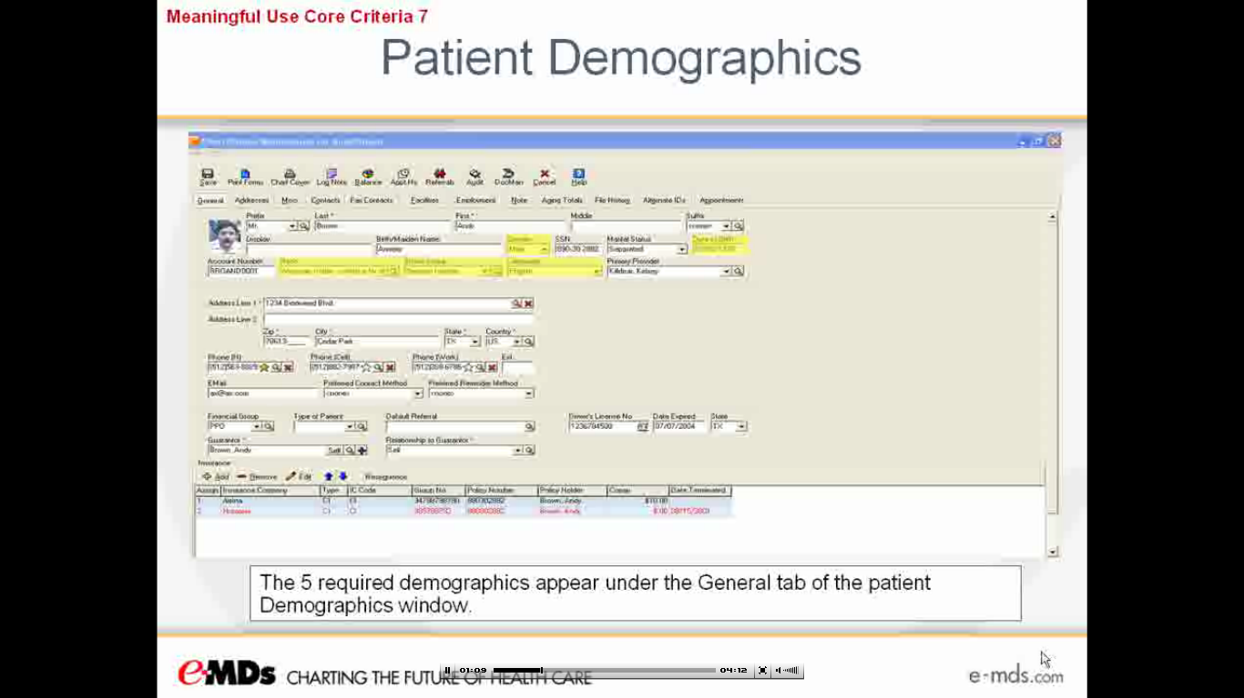
* You will need to set up these fields up as being required. See the Meaningful Use Core Criteria #7 in eMDs Video Library.
* If “Unknown” is entered, this will show up in the Office Visit note as “36 y/o Unknown Female. This is a known problem with eMDs and they are working on fixing this.

Core Criteria #8

* **Record and chart changes in the following vital signs: Height, Weight, BP, BMI & Growth Charts.**
* These must be recorded on 50% of all patients seen who are >2y/o
* This will be the responsibility of the nursing staff
* Height will needed to be obtained on all patients seen >2 y/o in order to calculate their BMI.
* BMI and Growth Charts will be calculated by eMDs automatically
* 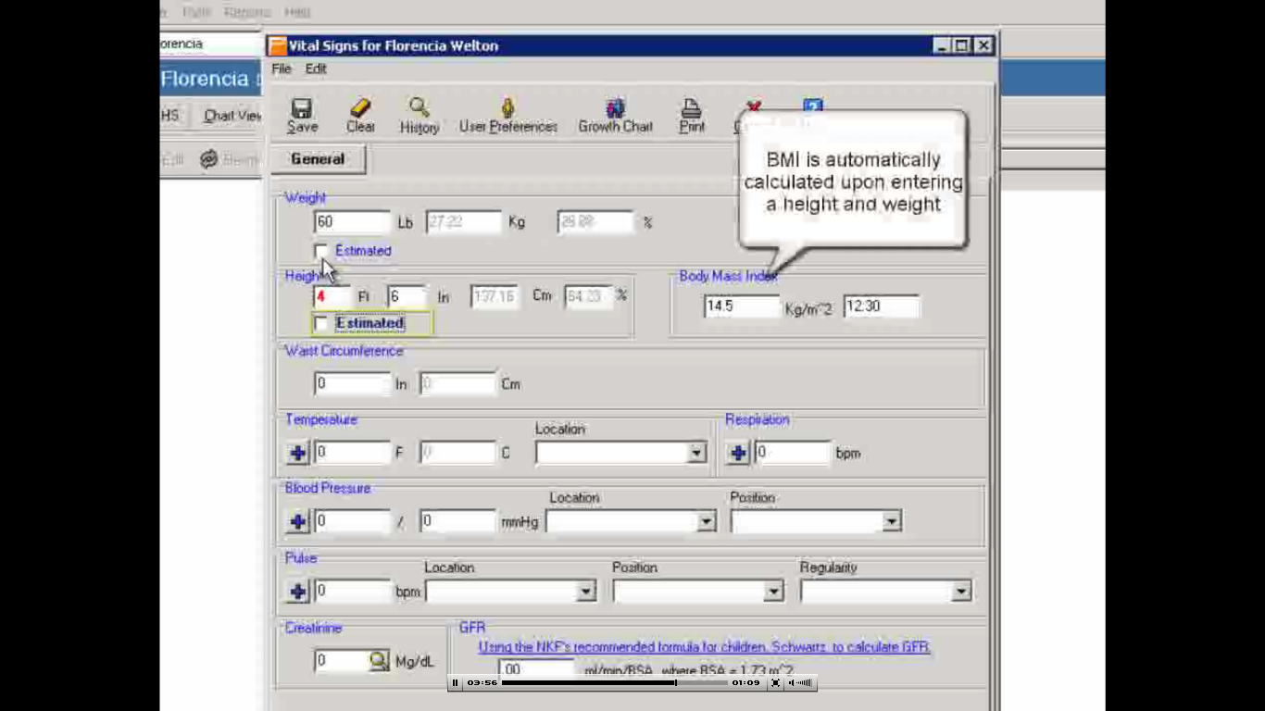

Core Criteria #9

* **Record smoking status for patients 13 years old or older**
* 50% of all patients 13 y/o or older who are seen to qualify for the MU incentive
* This will be achieved using custom CPT codes as documented in the Tobacco/Alcohol/Supplement template found in the Visit/HS
* 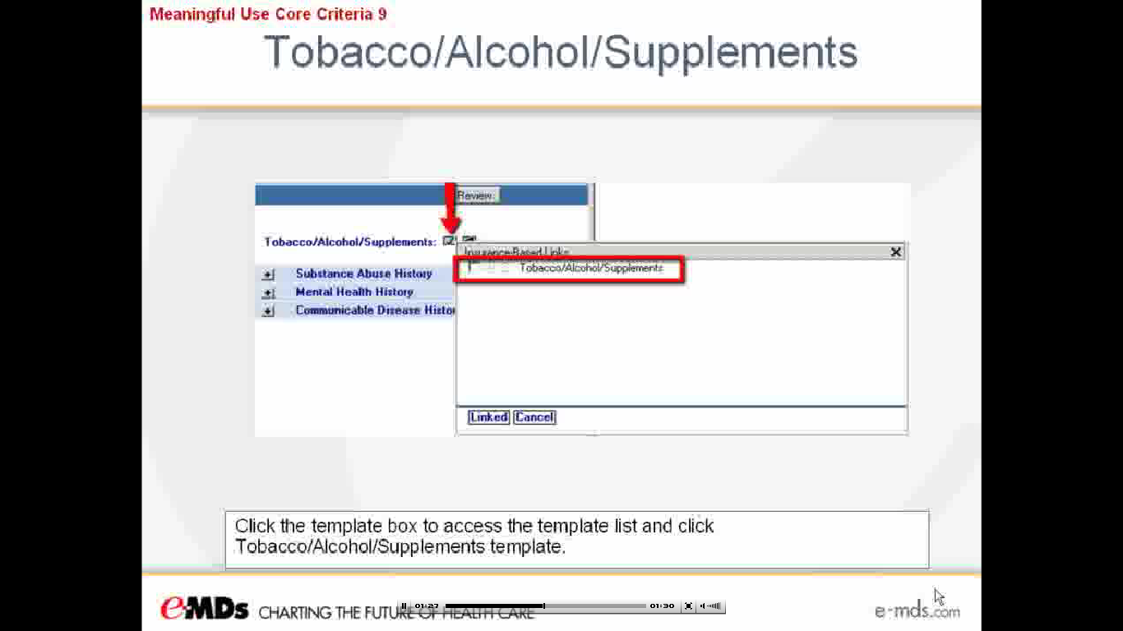
* 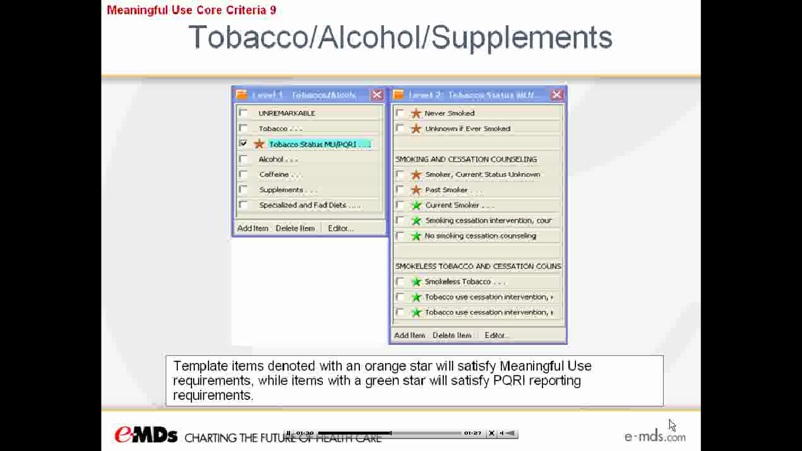
* This information can also be added thru all plan templates and will be noted in the office note as well to eliminate duplicate entry.
* 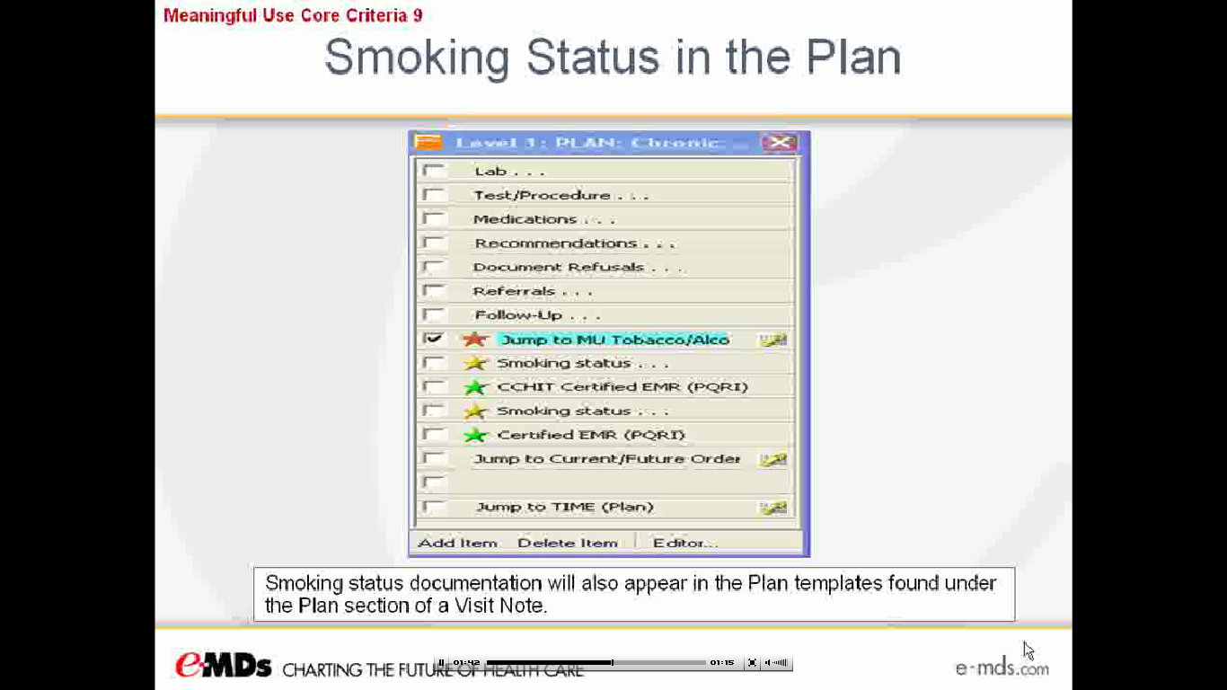

Core Criteria #10

* **Report Ambulatory Clinical quality measures to CMS or, in the case of Medicaid EPs, the States**
* Implement one Clinical Decision Support Rule thru Rule Manager.
* Users will set up and utilize the Rule Manager Module or Registry Processor in order to meet this requirement.
* In order to track patient compliance, a Crystal Report titled “Overdue Rules Report” can be run.
* 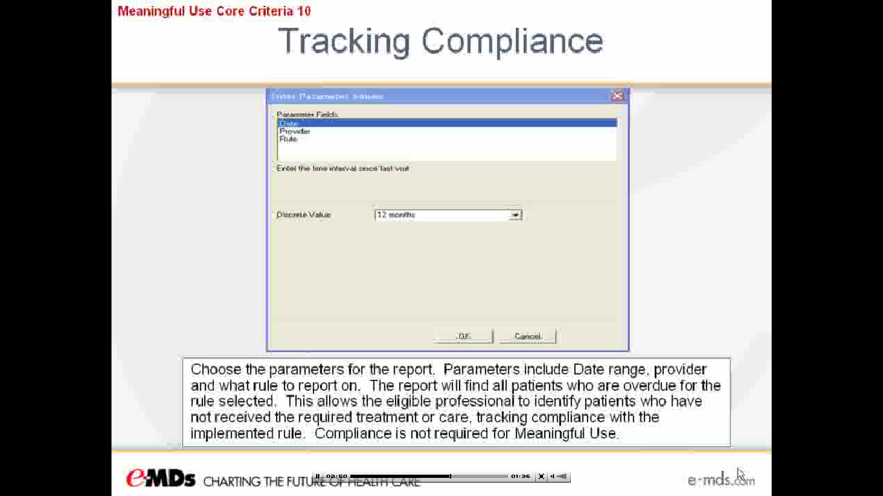
* No issues meeting this criterion for the Meaningful Use (MU) incentive. eMDs already provides this functionality.

Core Criteria #11

* **Implement one clinical decision support rule relevant to specialty or high clinical priority along with the ability to rack compliance with that rule.**
* To achieve this requirement, 3 core measures must be reported on as well as an additional 3 specialty/organization specific measures chosen from 38 available.
* These reports are listed as “NQF” or “PQRI”
* Rule Manager, Crystal Reports or Registry Processor will be needed
* This information will be obtained thru running specific Crystal Reports.
* No issues meeting this criterion for the Meaningful Use (MU) incentive. eMDs already provides this functionality.
* 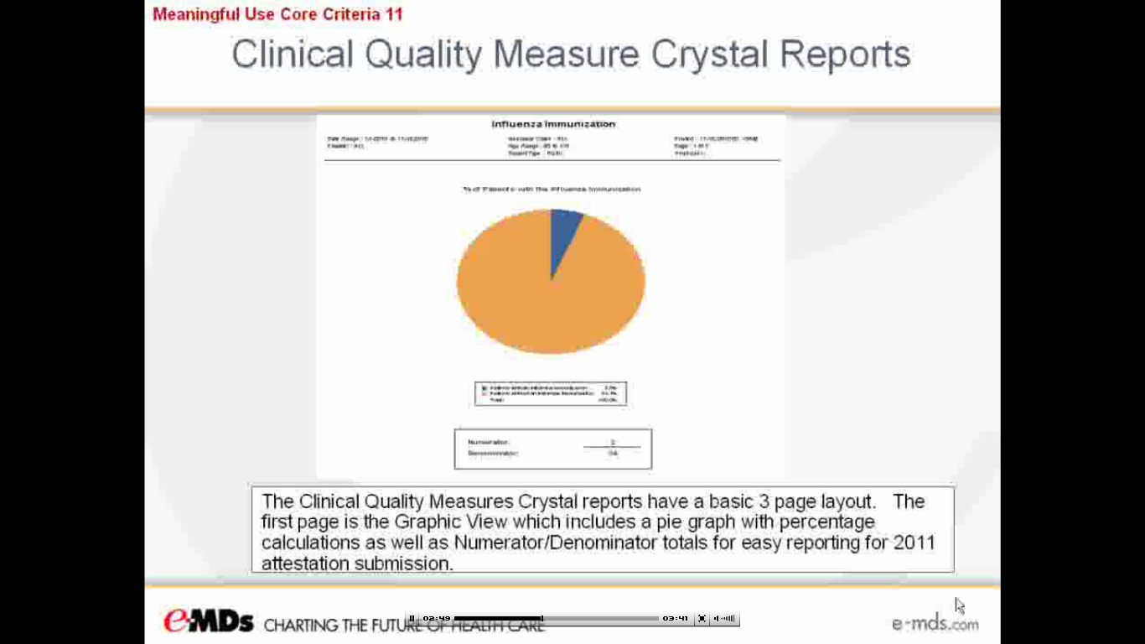

Core Criteria #12

* **Providing an electronic copy of patient health information within 3 days of request.**
* Continuity of Care Document (CCD)
* These requests must be completed within 3-days in 50% of Medicare patients to qualify for Meaningful Use incentive.
* Request can be made thru Log Note by making a TaskMan request
* 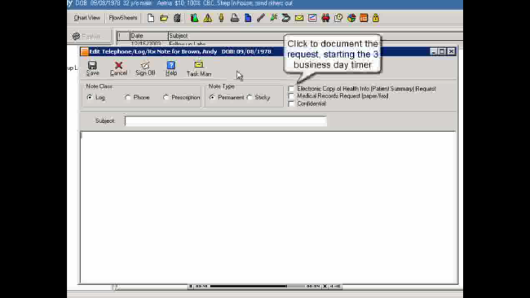
* By checking the “Electronic copy of Health Info” box, this starts the 3-day timer (see above)
* This requested Health Summary can be put on CD/Flash Drive or emailed to patient to allow uploading into another EMR. This allows communication with other offices using EMR.

Core Criteria #13

* **Provide clinical summaries for patients for each office visit.**
* 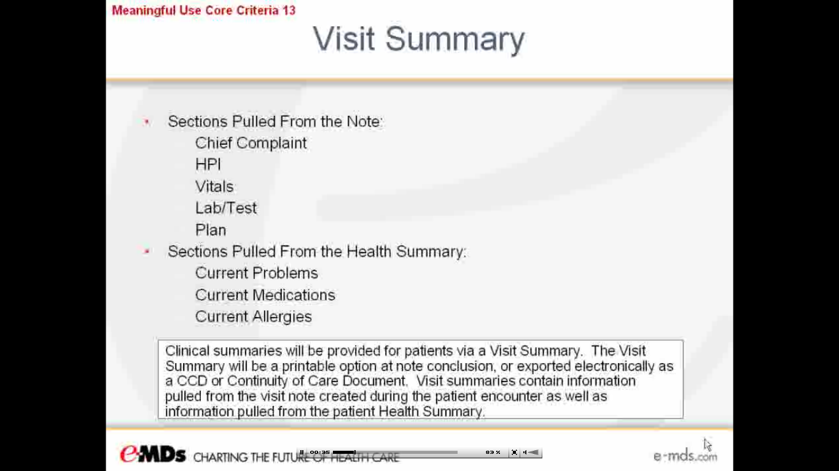
* This must be given to 50% of Medicare patients to qualify for Meaningful use incentive.
* Must be provided within 3 days of office visit.
* It can be provided in print format, transmitted thru patient portal, or electronically to flashdrive.
* 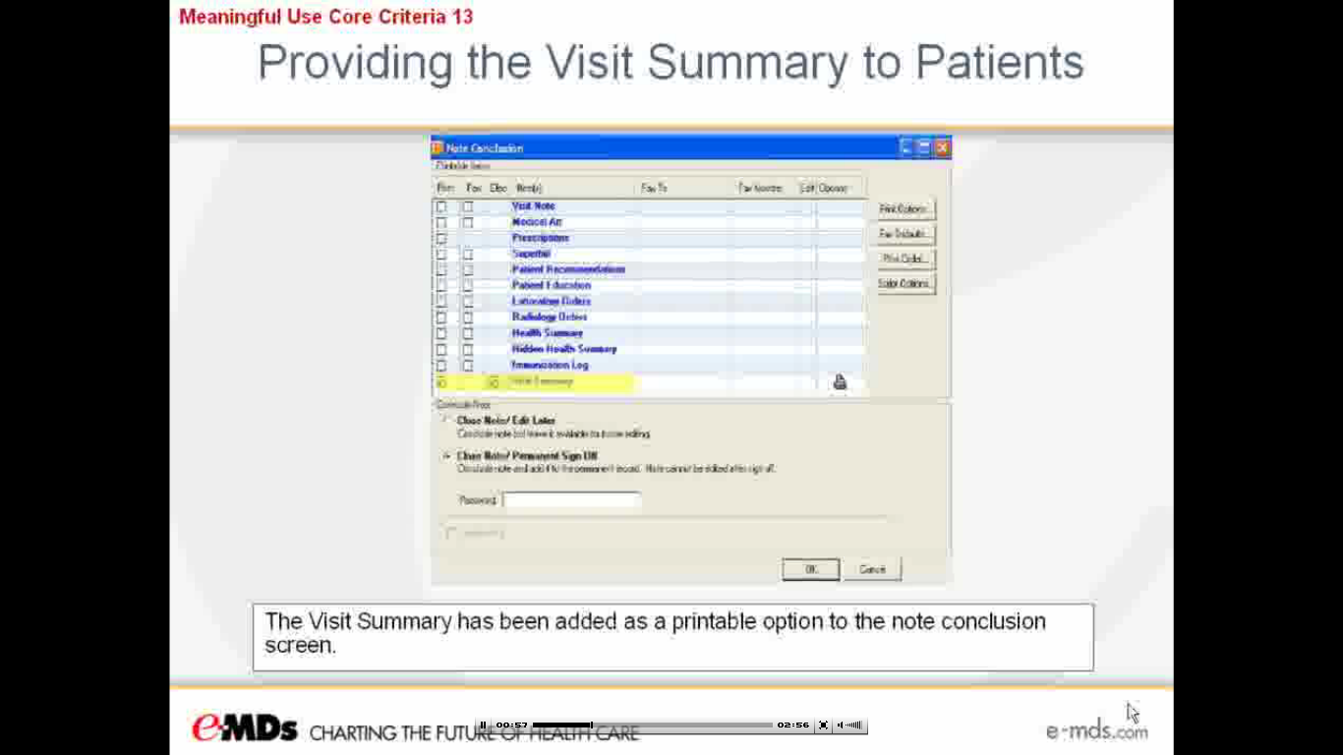
* Once the note is signed off, a copy of this Visit Summary is saved in the patient’s DocMan under the Office Visit folder.

Core Criteria #13-14

* **Exchanging relevant clinical information upon transition of care and security measures for protecting this health information.**
* #13--This would include any outbound or inbound transition of care such as patient being admitted to ER or Hospital and being transferred to/from another provider or nursing home.
* Clinical information will be exchanged utilizing the Chart Summary CCD referenced in Core Criteria #12.
* Import CCD within the patient’s chart or Docman. eMDs runs a demographic check & places the report in the patient’s DocMan.
* 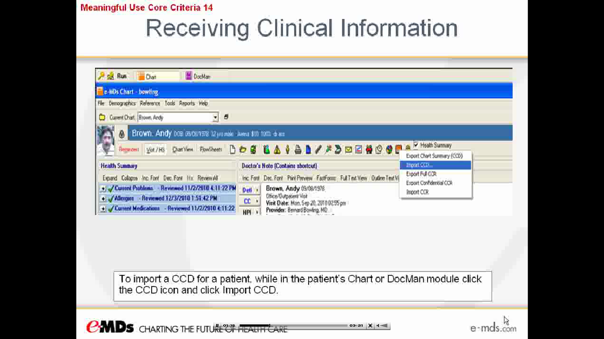
* Export of CCD can also be done within the patient’s chart or DocMan.
* 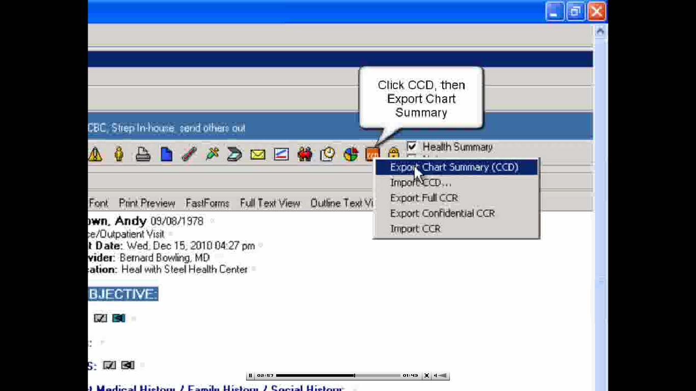
* Documentation of this transition of care can be entered within the office note under the Plan for future tracking.
* #14-Protect Electronic Health Information-eMDs EMR already has this capability.
* To satisfy this measure, the office must conduct or review a security risk analysis and implement security updates.
* No issues meeting this criterion for the Meaningful Use (MU) incentive. eMDs already provides this functionality.